ICEBERG DETECTION USING SATELLITE IMAGING AND IBM WATSON

INDEX

1. INTRODUCTION

1.1 Overview

1.2 Purpose

2. LITERATURE SURVEY

2.1 Existing Problem

2.2 Proposed Solution

3. THEORETICAL ANALYSIS

3.1 Block Diagram

3.2 Software Designing

4. EXPERIMENTAL INVESTIGATION

5. FLOWCHART

6. RESULT

7. ADVANTAGES AND DISADVANTAGES

8. APPLICATIONS

9. CONCLUSION

10. FUTURE SCOPE

11. BIBLIOGRAPHY APPENDIX

A. SOURCE CODE

1. INTRODUCTION:

1.1 OVERVIEW:

The main objective of this is to develop methods for detecting icebergs using satellite radar data and high spatial resolution images in the visible spectral range. The methods of satellite monitoring of dangerous ice formations, like icebergs in the Arctic seas represent a threat to the safety of navigation and economic activity on the Arctic shelf.

1.2 PURPOSE:

To build an accurate model for the detection of icebergs and successfully using the algorithm in ship navigation systems for avoiding the icebergs and save lives and billions of dollars.

2. Literature Survey

2.1 Existing Problem:

Build an algorithm to automatically identify whether a remotely sensed target is an iceberg or not. Often times an iceberg is wrongly classified as a ship. The algorithm had to be extremely accurate because lives and billions of dollars in energy infrastructure are at stake.

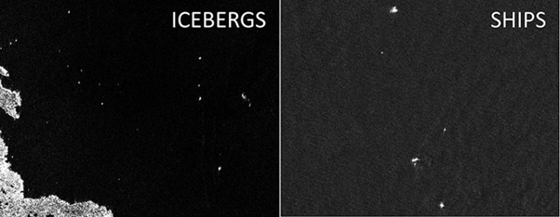

2.2 Proposed Solution:

The developed method of iceberg detection is based on statistical criteria for finding gradient zones in the analysis of two-dimensional fields of satellite images. The approaches proposed to detect icebergs from satellite data allow improving the quality and efficiency of service for a wide number of users with ensuring the efficiency and safety of Arctic navigation and activities on the Arctic shelf.

3. THEORETICAL ANALYSIS:

3.1 Block Diagram:

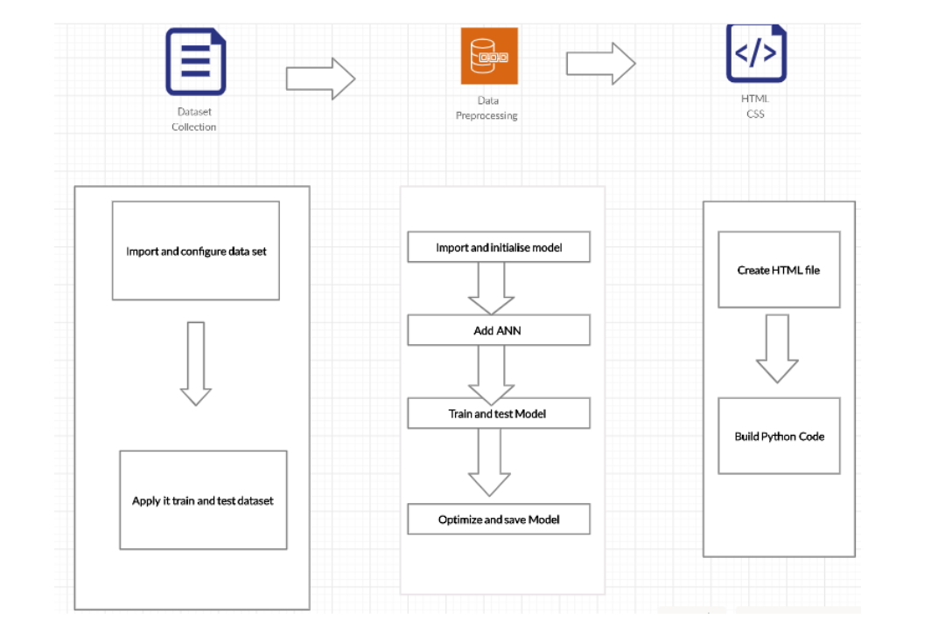

3.2 Hardware / Software Designing:

1. Strategy: Using ANN based neural networks Algorithm to predict the CCPP

electrical power output prediction

2. Dataset Creation: Data Collection

3. Data Pre-processing:

4. Importing Data Set

Evaluating Any Null Values

1. Training and Testing Dataset by applying Multi linear regression method.

2. Model Building:

1. Import Model Building Libraries

2. Initializing the model

3. Loading Pre-processing Data

4. Adding ANN and Dense layer

5. Configure Learning Process

6. Train and Test Model

7. Optimize and save the Model

1. Application Building

1. Create HTML file

2. Build Python Code

4.EXPERIMENTAL INVESTIGATION:

In this project, we have used the Iceberg detection dataset. This dataset will be having two folders i.e. test and train. In this test folder, we will be having two categories namely Iceberg and Ship, in which Icebergs contains the images having Icebergs and ships will contain images of ships, and has the same in the training folder. There are 2 classes of 710images in training set and 2classes of 192 images in test set.

5.FLOWCHART:

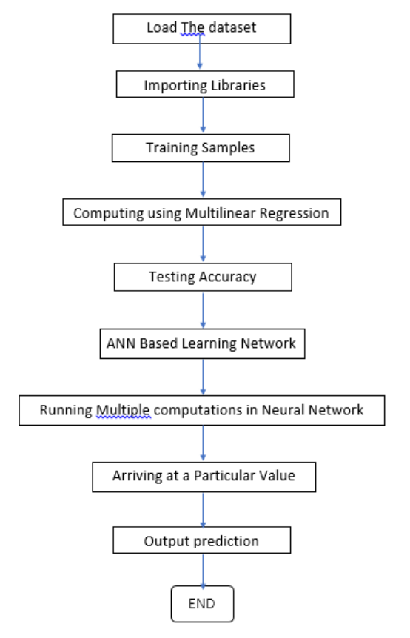

6.RESULT:

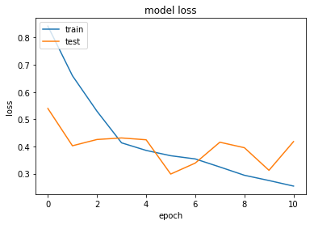

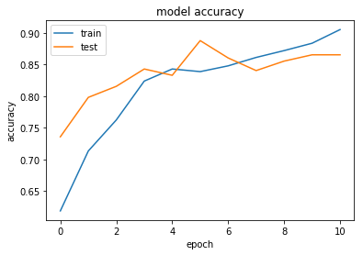

Both the training as well as the test set loss values are converging quite well. Also the model is able to achieve training and test set accuracy of 90% and 85% respectively in just 10 epochs.

7.ADVANTAGES AND DISADVANTAGES:

ADVANTAGES:

* We are able to detect Icebergs through satellite images and will be very useful for ship navigation and transportation vessels.
* It is easy to use and Implement
* It works on Real time and has low complexity

DISADVANATAGES:

* There might be issues faced with the connection to the satellite above to get real time images for processing and there may be delay caused.
* There is also the issue to connect to different satellites as the ship goes to various parts of the oceans.

8.APPLICATIONS:

* Used in Ship Navigation Systems to feature to avoid crashing into icebergs and navigating a safe course through the oceans.
* Minimizing human effort and cost efficient databases.
* Easy and simple interface to understand and help the user.

9.CONCLUSION:

I think this is one of the great examples where deep learning can be used to solve a challenging real-world problem. If we are able to detect and segment icebergs in an image, it would be of great help to the logistics and transportation team in northern countries like Sweden, Norway and Canada. It could bring a whole new dimension of transport for container ships and vessels by tracking icebergs from satellite images and videos in real-time.

10. FUTURE SCOPE: The extraction of the iceberg detection from the satellite imagery can be used in

* Digital cartography updating
* Multi-temporal change analysis
* Content-based image indexation

11. BIBLOGRAPHY:

Model Building

1. Dataset

2. Jupiter Notebook

Application Building

1. HTML file

2. CSS file

3. Flask

4. IBM Watson

1. SOURCE CODE:

HTML Code:

<html>

<head>

<meta charset="UTF-8">

<meta name="viewport" content="width=device-width, initial-scale=1.0">

<meta http-equiv="X-UA-Compatible" content="ie=edge">

<title>Artificial Intelligence</title>

<link href="https://cdn.bootcss.com/bootstrap/4.0.0/css/bootstrap.min.css" rel="stylesheet">

<script src="https://cdn.bootcss.com/popper.js/1.12.9/umd/popper.min.js"></script>

<script src="https://cdn.bootcss.com/jquery/3.3.1/jquery.min.js"></script>

<script src="https://cdn.bootcss.com/bootstrap/4.0.0/js/bootstrap.min.js"></script>

<link href="{{ url_for('static', filename='css/main.css') }}" rel="stylesheet">

<link rel="stylesheet" href="{{url_for('static',filename='css/main6.css')}}">

<style>

.moveright {

text-align:right;

}

.moveleft {

text-align:left;

}

.movecenter{

text-align: center;

}

.movejustify{

text-align: justify;

}

.images_span{

padding: 40px;

}

.detect{

padding-left: 275px;

padding-right: 200px;

word-spacing: 20px;

}

.button{

background-color:blue;

color:white;

}

div.ex1{

padding:25px;

width:30px;

background-color:yellow;

}

div.ex2{

background-color:rgb(0,191,255);

color:rgb(162,0,175);

padding:35px;

}

.heading_bar{

padding-right: 200px;

padding-top: 10px;

padding-bottom: 10px;

}

.navigation-buttons{

padding-right : 50px;

}

.bg-dark {

background-color: #42678c!important;

}

#result {

color: orange;

}

</style>

<script>

function pageRedirect(){ window.location.href="https://www.britannica.com/science/iceberg/Iceberg-detection-tracking-and-management"

}

function pageRedirect2(){

window.location.href="https://en.wikipedia.org/wiki/List_of_ships_sunk_by_icebergs"

}

</script>

</head>

<body style="background-color: rgb(235, 217, 235);">

<nav class="navbar navbar-dark bg-dark">

<div class="container">

<div class="heading_bar">

<a href="#" style="color:white; font-size: x-large;"><strong>ICEBERG DETECTION</strong></a>

</div>

<div class="navigation-buttons">

<button class="btn btn-primary btn-lg " type="button" onclick="pageRedirect()">Info</button>

<button class="btn btn-primary btn-lg " type="button" onclick="pageRedirect2()">Case-Study</button>

</div>

</div>

</nav>

<h2 style="color:red" ><strong>What’s Importance of detecting an IceBerg ?</strong></h2>

<p class="movejustify">The Ocean is filled with obstacles and contains Icebergs which are threatening to

safety of the ship and its people. Especially in colder regions like the Arctic and Antarctic the

detection of icebergs are very essential for navigating a safe passage through the ocean to

avoid hitting an iceberg and is done through building image processing using satellite imagery

and should be able to detect the difference between a iceberg and a ship.</p>

<h2 class="movejustify" style="color:rgb(255, 0, 55)">What is the need to detect Iceberg?</h2>

<p class="moveleft">Methods of satellite monitoring of dangerous icebergs in the Arctic and Antarctic Oceans are a threat to the safety of navigation for ships and economic condtions..</p>

<br>

<br>

<br>

<h2 class="movecenter" style="color:blue">Images of <strong> Ship</strong> hitting<strong> Iceberg</strong></h2>

<span class="images_span">

<img src="https://encrypted-tbn0.gstatic.com/images?q=tbn%3AANd9GcTOLveW5N5bKvw_Pm3hsE0_fyieNhMfAPKWfQ&usqp=CAU",alt="img1" width="250" height="200">

<img src="https://encrypted-tbn0.gstatic.com/images?q=tbn%3AANd9GcQ8y445Rd08FK4-Mto3xvqkt3MKf4fxA9q1pA&usqp=CAU",alt="img2" width="250" height="200">

<img src="https://media1.s-nbcnews.com/j/msnbc/Components/Photo_StoryLevel/071123/071123_explorer_hmed_9p.fit-760w.jpg" alt="img3" width="250" height="200">

<img src="https://i.ytimg.com/vi/lHDia6SVWhc/hqdefault.jpg" alt="img4" width="250" height="200">

<img src="https://encrypted-tbn0.gstatic.com/images?q=tbn%3AANd9GcQmReYH5G3ea8abgPrvjRB16vtNbBgo_Aj5HQ&usqp=CAU",alt="img5" width="250" height="200">

</span>

<br>

<br>

<br>

<h2 class="movecenter">Detect the image</h2>

<span style="color:black" class="detect">

<img src="https://encrypted-tbn0.gstatic.com/images?q=tbn%3AANd9GcQlsQMi3IG1VVuYIgG2l6RP78_h_cBMr8mA8A&usqp=CAU",alt="ice" width="300" height="250">

<strong>ICE</strong> <em>OR</em> <strong>SHIP</strong>

<img src="https://encrypted-tbn0.gstatic.com/images?q=tbn%3AANd9GcT2vejUS44qNmWxka7-Vp-ReT47eRI48TTOJQ&usqp=CAU",alt="ship" width="300" height="250">

</span>

</div>

<br>

<br>

<h4 class="movecenter" style="color:black">Upload Image Here</h4>

<div class="movecenter">

<form action="http:/localhost:5000/predict" id="upload-file" method="post" enctype="multipart/form-data">

<label for="imageUpload" class="upload-label">

Choose...

</label>

<input type="file" name="image" id="imageUpload" accept=".png, .jpg, .jpeg">

</form>

<div class="image-section" style="display: block;">

<div class="img-preview">

<div id="imagePreview">

</div>

</div>

<div>

<button type="button" class="btn btn-primary btn-lg "id="btn-predict">Predict!</button>

</div>

</div>

<div class="loader" style="display:block"></div>

<h3 id="result">

<span> </span>

</h3>

</div>

</body>

<footer>

<script src="{{ url_for('static', filename='js/main.js') }}" type="text/javascript"></script>

</footer>

</html>

FLASK PROGRAM:

import numpy as np

import os

from keras.models import load_model

from keras.preprocessing import image

import tensorflow as tf

global graph

graph = tf.compat.v1.get_default_graph()

from flask import Flask , request, render_template

from werkzeug.utils import secure_filename

from gevent.pywsgi import WSGIServer

app = Flask(__name__)

model = load_model("iceberg_model.h5")

@app.route('/')

def index():

return render_template('index.html', methods= ['GET'])

@app.route('/predict',methods = ['GET','POST'])

def upload():

if request.method == "POST":

f = request.files["image"]

basepath = os.path.dirname(__file__)

print("current path", basepath)

filepath = os.path.join(basepath,"uploads",secure_filename(f.filename))

print("upload folder is ", filepath)

f.save(filepath)

img = image.load_img(filepath,target_size = (75,75))

x = image.img_to_array(img)

x = np.expand_dims(x,axis =0)

#with graph.as_default():

preds = model.predict_classes(x)

pred = preds[0][0]

if not pred:

text ="Be Careful the is an Iceberg ahead."

else:

text = "Its Safe to go it's just a Ship"

print(text)

return text

if __name__ == '__main__':

app.run()

|  |  |
| --- | --- |
|  |  |
|  |  |